Hitler weakened after Stalingrad

21st February 1943: The Fuhrer's outward show of confidence conceals a failing physical health
FEB 21

SAVE |  | ▷ LISTEN

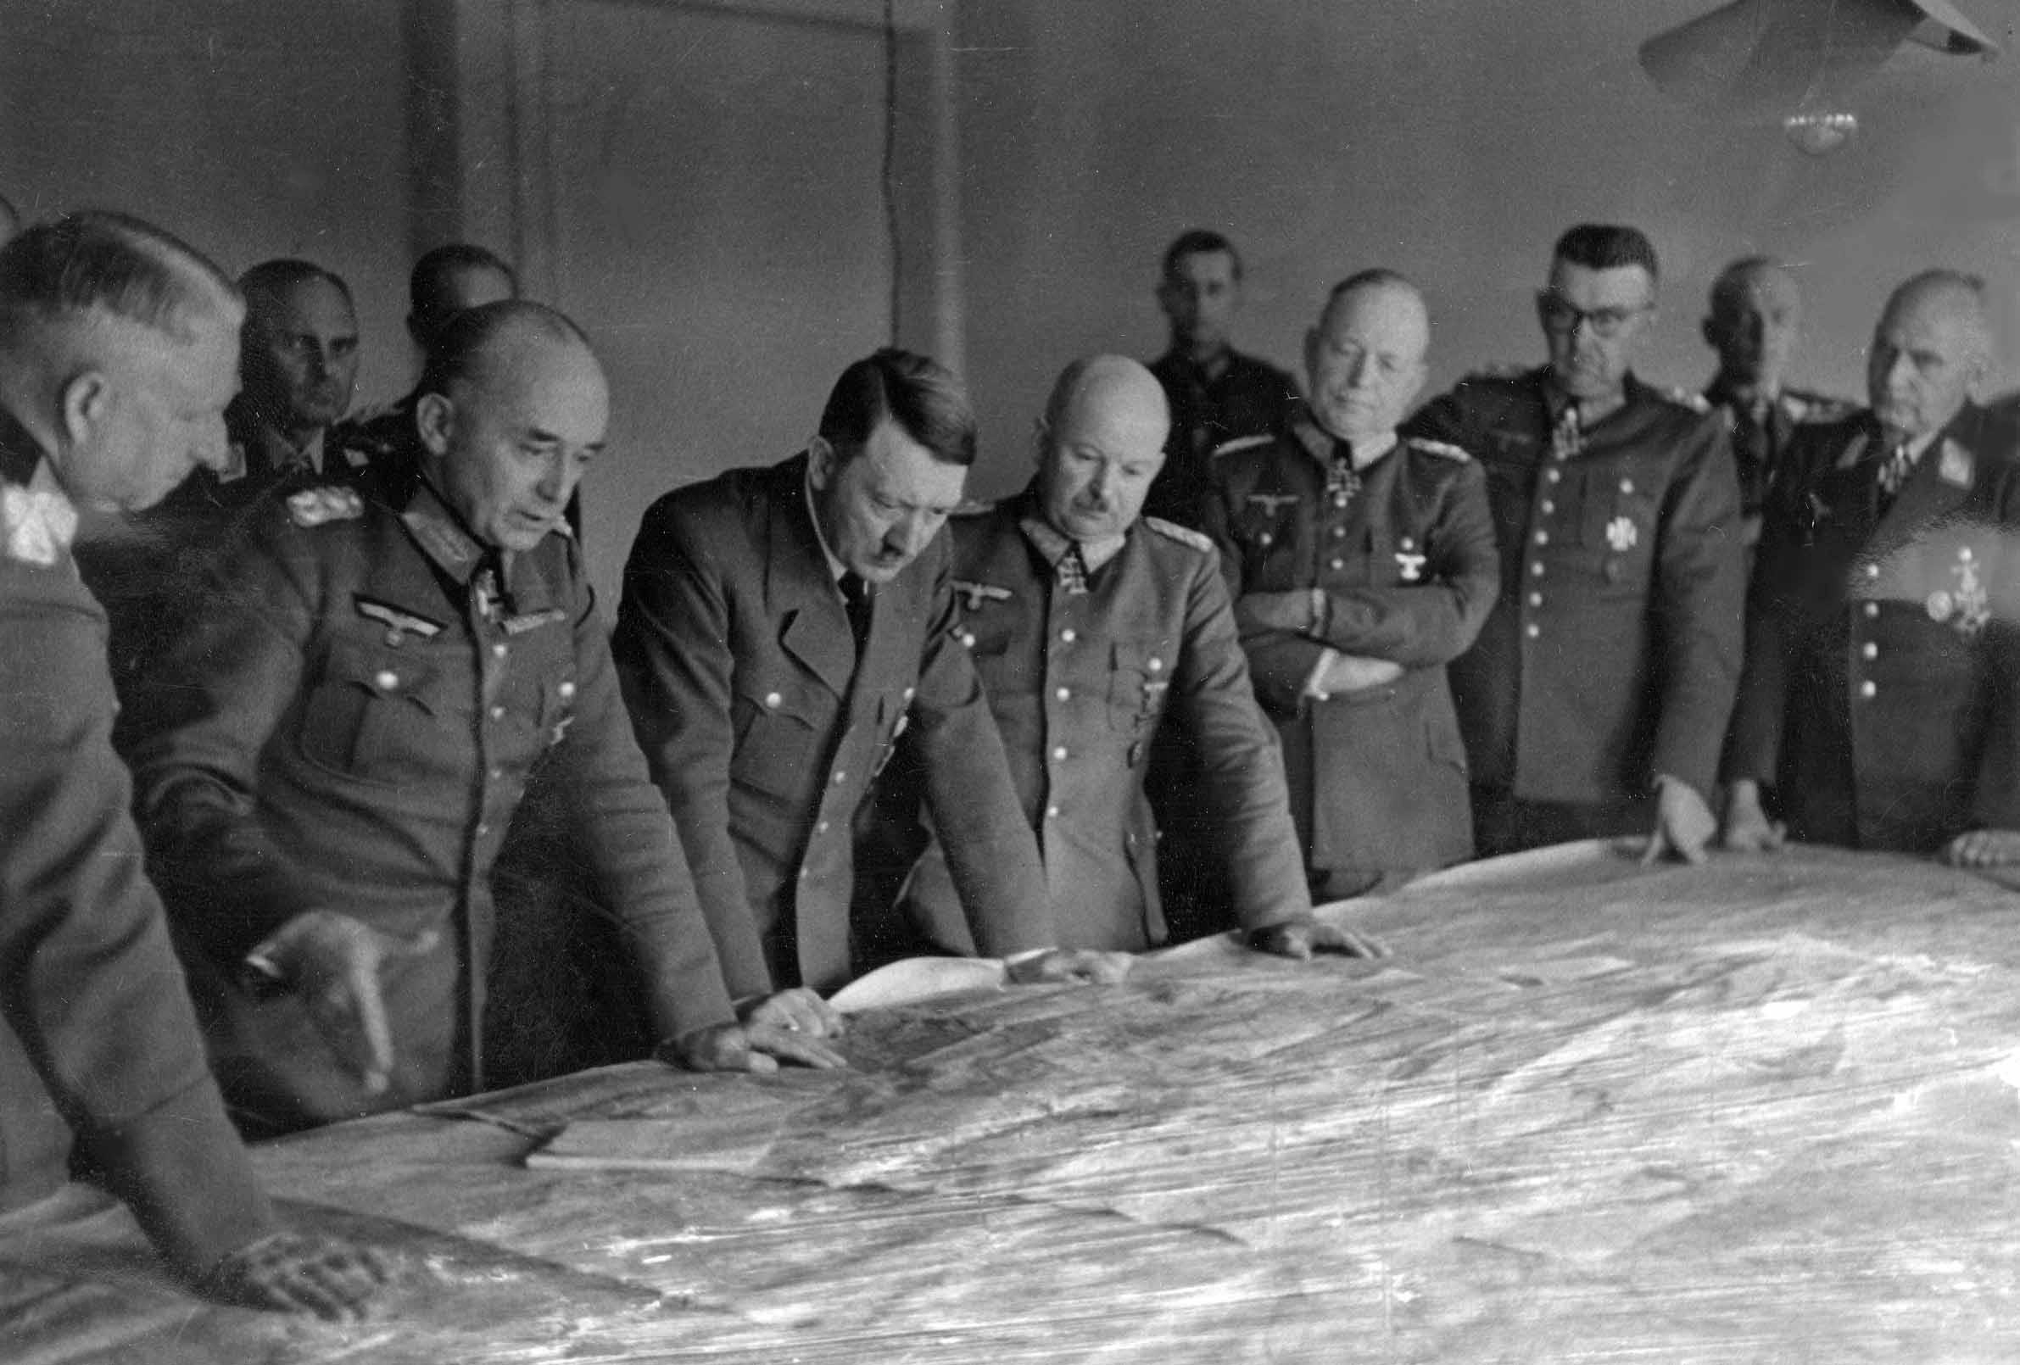
Adolf Hitler and his generals at the situation conference at Manstein’s Heeresgruppe Süd in Ukraine, 17th February 1943.
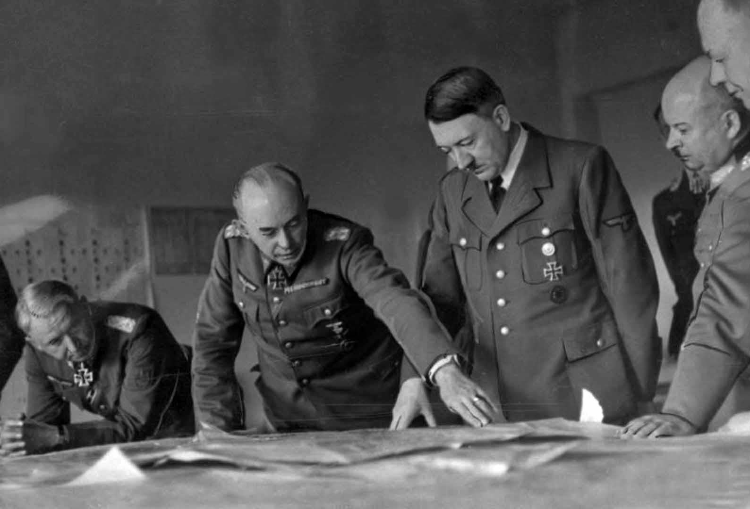
Manstein on very left, with General Richard Ruoff, commanding 17th Army, explaining something to Hitler. Ruoff had overseen the Caucasus campaign. His troops had now been withdrawn, but Hitler insisted that the ‘Kuban bridgehead’ be held for most of 1943 - as a jumping-off point for another attack into the Caucasus, as he hoped.
In front of his generals Hitler still managed to present a confident facade, even if they sometimes noted that he was unwilling to really engage with the conduct of the campaign in the east. As Manstein observed, Hitler had “considerable psychological skill” in handling those around him to cover his evasiveness.
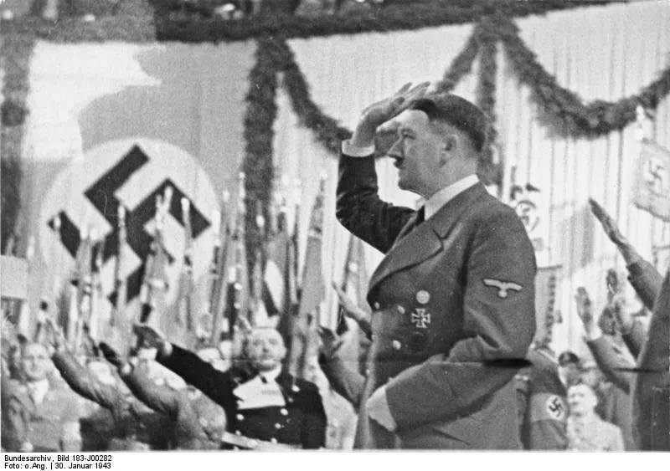
Hitler was still capable of rousing huge audiences of loyal Nazis to a state of frenzy, as he demonstrated on the 10th anniversary of the Nazis coming to power.
But while the Nazi Party remained devoted to the Fuhrer and ardent party members were proclaiming how much they still wanted to follow him, the man himself was beginning to crumble. The strain of the defeat at Stalingrad, which he blamed on everyone but himself, was beginning to have a physical effect on Hitler.
His image as a remote military genius, guiding the German nation through treacherous times, was carefully cultivated by the propaganda machine. The godlike mystique was maintained and a remarkable number of people kept their faith in him right up to the end.
There was no possibility that those who knew him personally could ever publicly reveal any real facts about the man. Many of those around Hitler were probably so blindly loyal that they could not see what was happening to him.
A picture was only developed from his personal aides after the war, when his personal valet, Heinz Linge, and his SS adjutant, Otto Guensche became prisoners of the Soviets. The Hitler Book¹ remained a state secret for a long time, a personal entertainment for the dictator who finally prevailed in the East, Stalin:
The obliteration of the German army at Stalingrad had a dreadful effect on Hitler.
He certainly would not have survived it had it not been for the stimulating injections of his personal physician Morell, administered every second day after breakfast. He began to have nervous stomach cramps. Because he was in extreme pain he had to keep to his bed for several hours a day. Linge, who administered the opium prescribed by Morell, could not help seeing that he was writhing in agony.
The attacks of nervous irritation increased. One moment Hitler's collar was too tight and was stopping his circulation; the next his trousers were too long. He complained that his skin itched. He suspected poison everywhere, in the lavatory cistern, on the soap, in the shaving cream or in the toothpaste, and demanded that these be minutely analysed. The water used for cooking his food had to be investigated as well.
Hitler chewed his fingernails and scratched his ears and neck until they bled. Because he suffered from insomnia, he took every possible sleeping pill. His bed was warmed with electric blankets and cushions.
He was short of breath, and as a result he asked that an oxygen cylinder be set up in his bedroom from which he frequently inhaled. He ordered that the temperature in his room be kept at a constant 12 degrees, because he believed that low temperatures had a refreshing effect on him. Participants at his briefings often left the room because they were cold and went somewhere to warm up.
He scarcely ever left his bunker now. Only in the morning before breakfast would he take his German shepherd Blondi out for ten minutes, when she would stay at his side. This huge, trained animal obeyed him alone, growling at everybody else, and guarding him day and night. Even during conferences she lay at his feet.
After lunch Hitler would stretch out in his clothes on his bed and stay there until the evening. Then he would go to the evening situation report that took place at 9.00 every day.
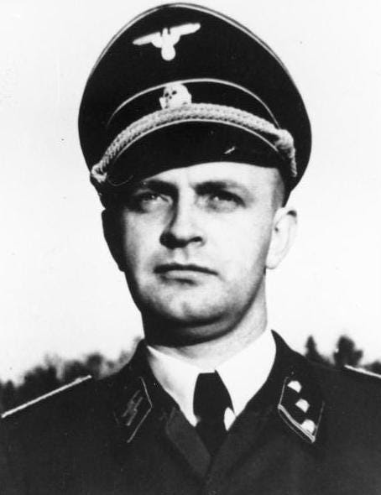
Hitler’s personal valet., SS-Obersturmbannführer Heinz Linge (1913-1980). Besides accompanying Hitler on all his travels, he was responsible for the accommodations and all the servants, mess orderlies, cooks and maids.
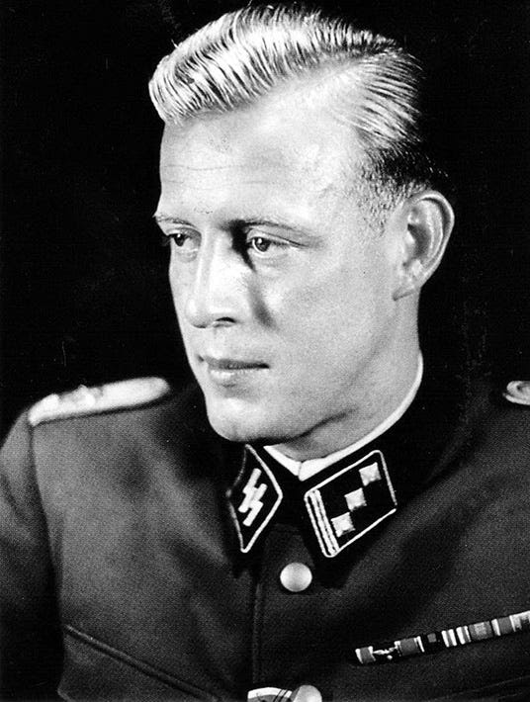
SS-Untersturmführer Otto Günsche (1917-2003) was posted to Adolf Hitler’s personal adjutant staff in January 1943, staying for a few weeks before leaving to get combat experience with Leibstandarte SS Adolf Hitler. He returned to serve Hitler from February 1944 to the end.
1
Hitler Book

